Compass deviation plugin for OpenCPN

This plugin could help you to make a deviaton table for your compass. If it is an electronic compass sending nmea, then an extra nmea sentence with true north heading can be generated.

For determining a deviation on a specivic compass course you must, some way or another, compare a true bearing/course with a compass bearing/course.
Finding a true bearing to a point can be done easy by: Drop a waypoint on a mark, and start navigating to this mark. In the popup route window you can read the true bearing/course to that point. Another possibility is using the sun. On a given position and time the true bearing of the sun can be calculated. (The calculation is done by the plugin)

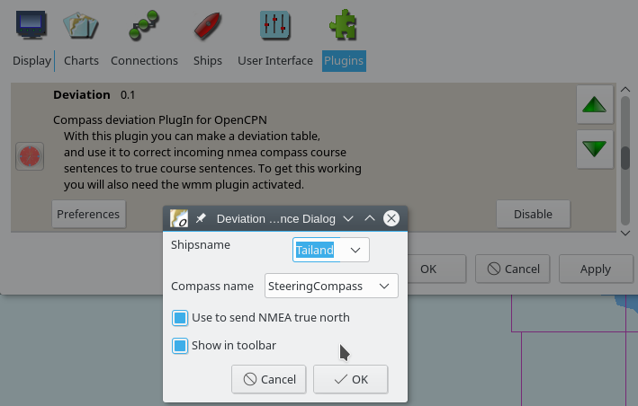
Start with installing the plugin the usual way. Activate the plugin by enable in the Options→plugin menu. Here you can also set the preferences.
Enter your ships name and a compass name. For now make sure that the “Show in toolbar” option is checked.

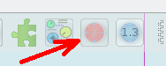
After ‘OK’ an extra button will showup in the toolbar.

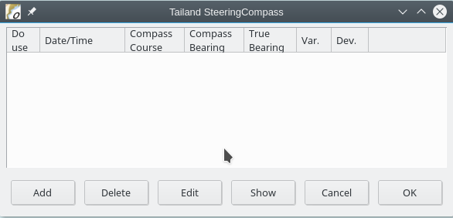
After clicking the toolbar button en emty list with check bearings will popup. By clicking ‘Add’ we can enter a deviation checkpoint.
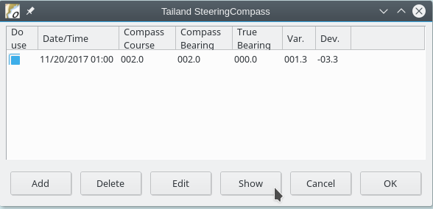
Here we steaming to a point straight north (000) and reading a compascourse of 002 degrees.
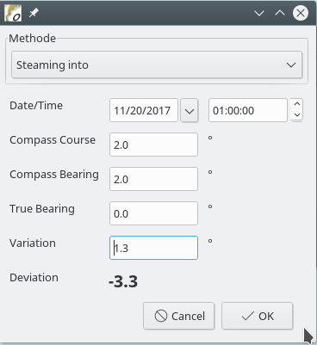

When using the sun as a true bearing point, make sure to use the correct time. On most places the azimuth (bearing) of the sun is changing about 1 degree every 4 minutes.
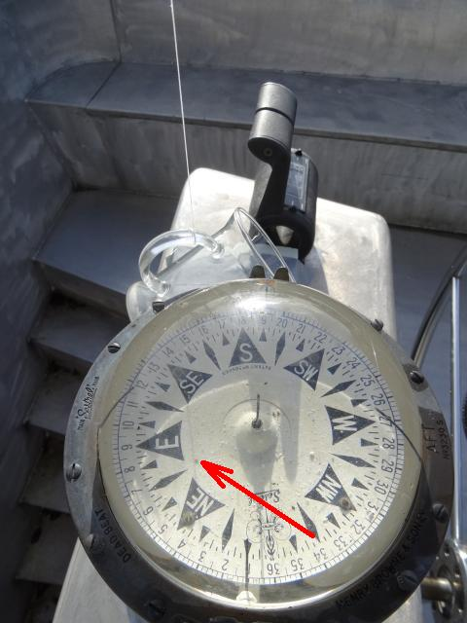
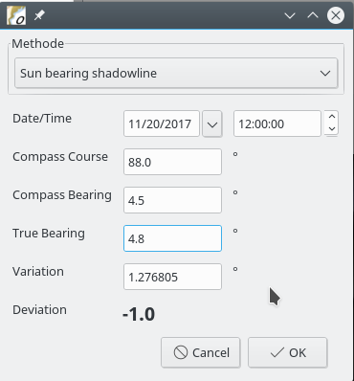
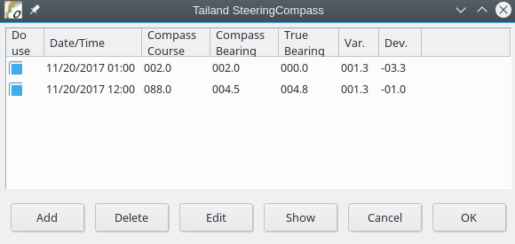
My compass does have a shadow pin in the midle of the rose, wich makes it easy to make a bearing. If your compass does not have one you might use the trick with a thin line and a weight. Here I use my thee cup as weight. In reality you must make sure that the shadow line of the rope runs over the midlepoint of the rose.

And add the check to the list. In theory taking 5 check points is enough, hoever that is theory. In practise try to make 8 checkpoints. Starting at a compass course 000º and from there have one every 45 degrees. Where 000º should be read as “something between 345º and 015º”.
After completing the list, a click on show will bring up the deviation table. Her I used some fake values, and as the points are showing in the graph you can see that the resulting curve is not vere exact. You are suposed to do better.
In case of an electronic compass sending a heading the deviation for the current heading is shown in the toolbar button now. Also if it was checked in the prefference a new nmea sentence is send with the true heading ($--HDT).
It is also possible to print the deviation table to paper.

